

**Mobile Application Development (S21MAD2101MA)**

**Mad 400 - iOS Development**

**Assignment 1 – Part 1**

**Submitted By: Ritesh Poudel**

**Student Id: A00120054**

**Submitted to:**

**Dr. Manhar Kapoor**

**Date: July 14, 2021**

Table of Contents

XCode 2

Installation 3

Windows PC 3

MacBook 3

XCode Capabilities 3

Guide 4

Creating Project 4

XCode Interface 7

Toolbar 8

Navigation Area 9

Editor Area 10

Utility Area 10

Debug Area 11

Getting Used to with XCode 12

Font and Color 12

Tab Bar 12

Editor 13

Developer Documentation 13

Quick Help Inspector 14

Attribute Inspector 15

Size Inspector 16

References 17

# XCode

XCode is a software package which is used by programmers mainly software engineers and developers so as to write software for Mac OS X, iOS devices like iPods, iPhones, iPads, the Apple watch and now the Apple TV. XCode is a type of package called an IDE (Integrated Development Environment) with editors, compilers, and other software tools that work together to help you write your software, compile it, load onto a virtual device, debug it and after completing your software, you can run your app according to your need and ultimately submit or launch it to the Apple App store.

# Installation

## Windows PC

For windows pc, XCode is installed with the help of VirtualBox and by installing XCode SDK on windows OS, you can create and develop basic apps on windows PC. Before installing, make sure of the following system requirements.

* Working Mac OS X virtual machine or VMware or VirtualBox
* Download XCode package from Apple
* At least Dual-core Intel Processor
* Minimum 2GB of RAM but 4GB and above is recommended

## MacBook

For MacBook, installation of XCode is easy, you can simply download it from Apple App Store and is ready for use. For XCode 11 and above, it requires macOS 10.14.4 or later and 7.6 GB of hard drive space but in real it will take about 20GB space after installation.

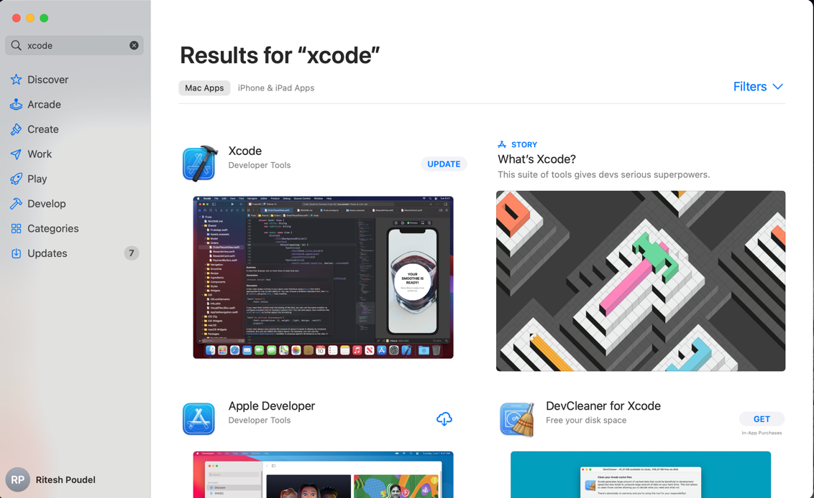

*Screenshot: Downloading XCode from App Store*

# XCode Capabilities

XCode is Apple’s IDE which is made for producing software on Mac for use on iOS, iPadOS, macOS, tvOS and watchOS which is free to download and used by developers to create iPhone and iPad apps, as well as programs for the mac.

* IDE for macOS
* Free to download and use
* Code editor offers suggestions and corrections
* Support for Swift and other languages
* Interface design tools

As XCode is owned by Apple so it is primarily used for the development of apps within its own ecosystem but it can also be used for writing source code in a variety of languages for use in other projects.

XCode supports writing programs in Swift, AppleScript, c, C++, Objective-C, Objective-C++, Python and Ruby and with the help of third-party support, it was also available for number of other languages as well.

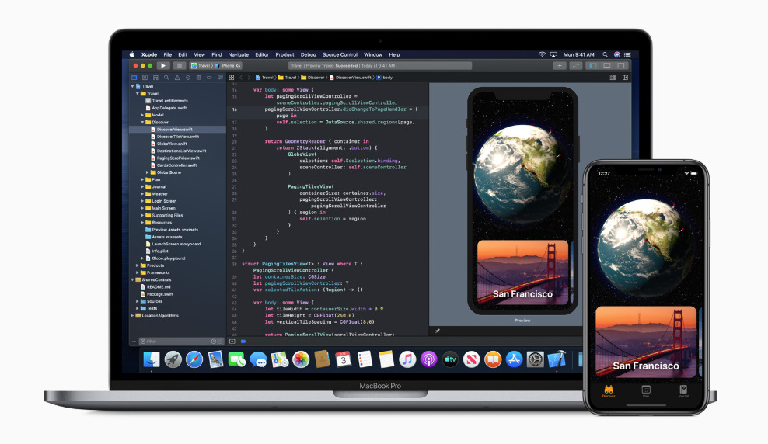

*Screenshot: XCode interface along with simulator*

# Guide

## Creating Project

The following steps can be performed so as to create a new project on XCode.

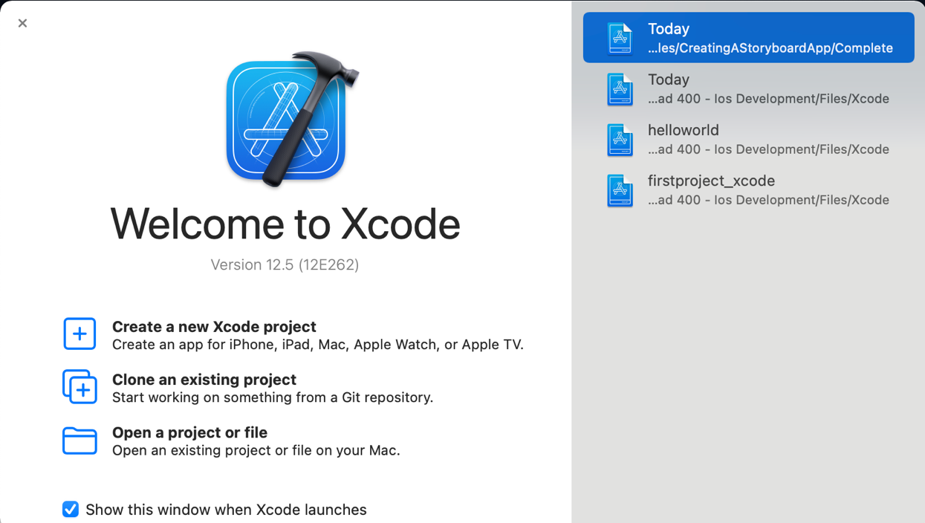

*Screenshot: Selecting option for creating new project or opening existing project*

After opening XCode, the very first screen you see is this where you can choose either create a new project or create an existing project or open an project or file, if you have running XCode file already.

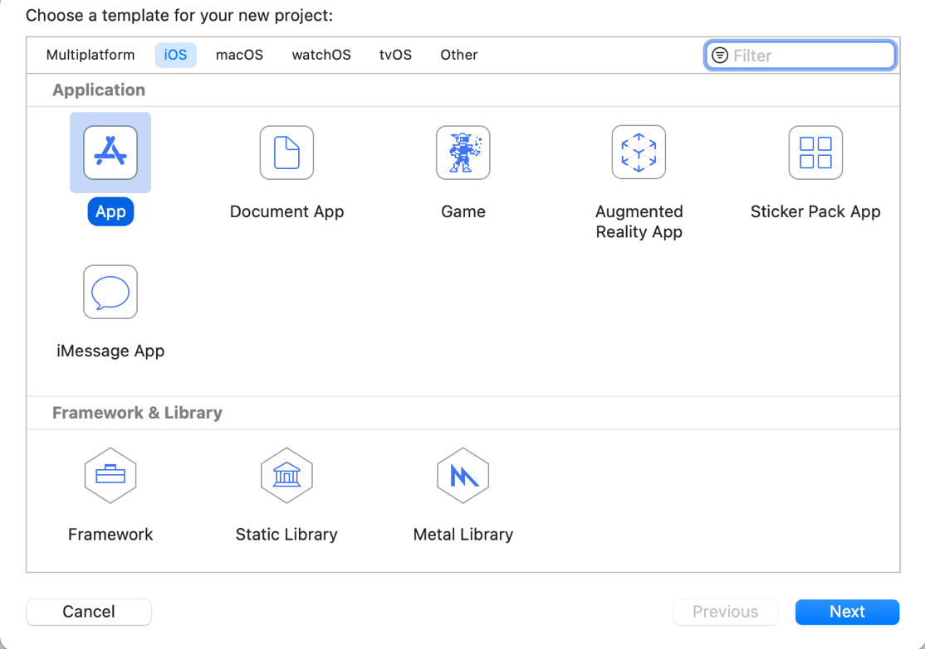

*Screenshot: Selecting for which platform you are going to develop*

Here, you can select for which platform you are going to develop the app or software such as iOS, macOS, watchOS, tvOS or other and simply select Next after that.

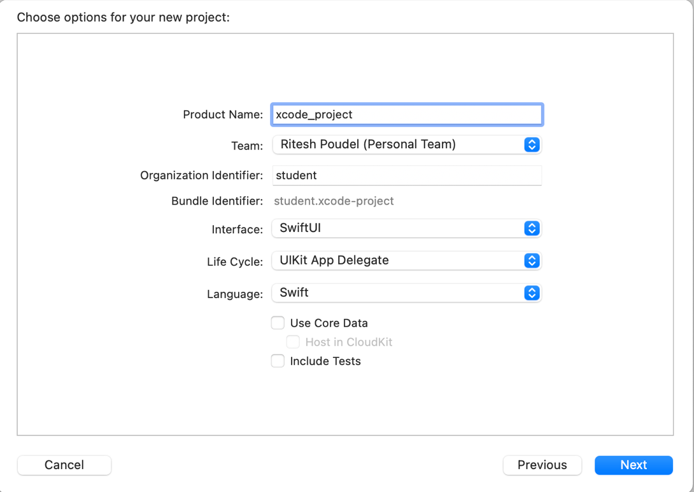

*Screenshot: Providing project name and interface*

Here, you can select the name for your project, Team will be the name or person developing it, organization identifier can be selected according to your choice and at interface section, you can choose either SwiftUI or Storyboard, select on which language you want to write the code such as Java or Kotlin and at last simply click Next.

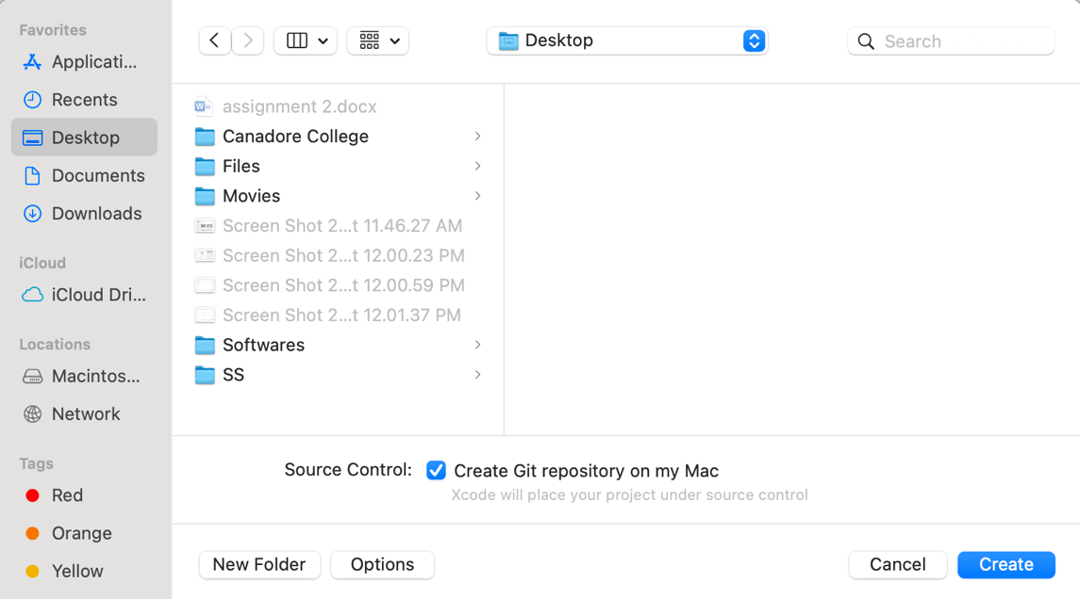

*Screenshot: Path to save the created file on your computer*

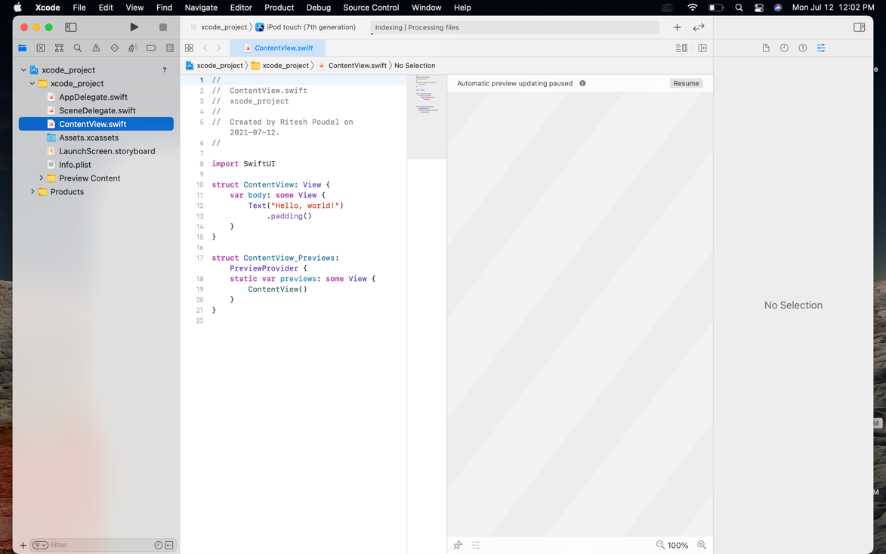

*Screenshot: Main screen of XCode for the recently created project*

This is the main screen of XCode after you create the project and here you can write all the code for your software.

## XCode Interface

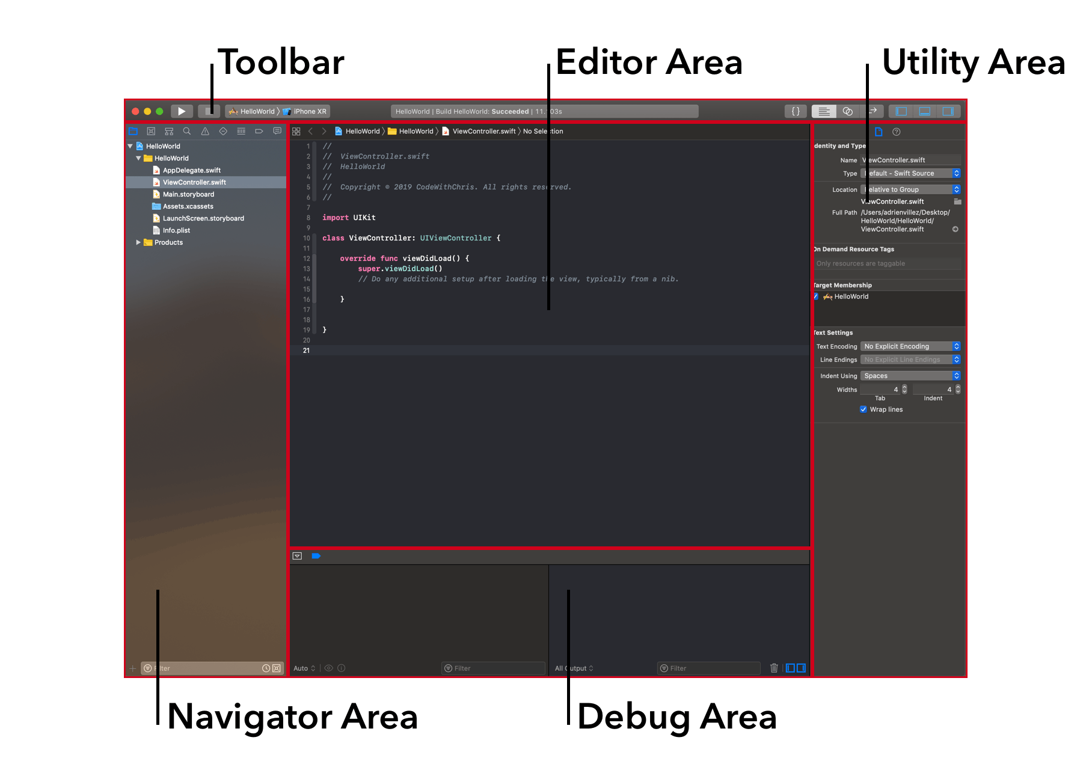

*Screenshot: Interface of XCode*

### Toolbar

Toolbar is the top most area of the XCode where Play button is present at the first which helps to launch our app and on the next of which you can see a stop button, which will be in inactive state until you run the app. On the right of which you can see the project name and simulator you want to select for your project such as iPad, iPhone 5, iPhone 6, iPhoneX, iPhone 12 pro and mostly all of the apple mobile devices.

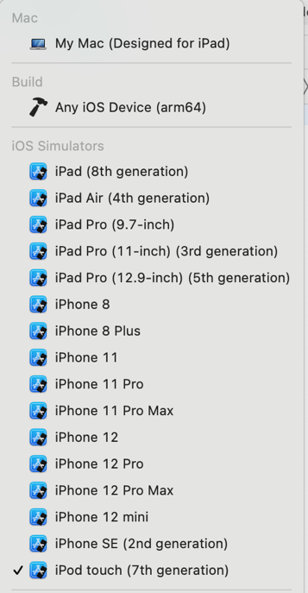

*Screenshot: Device and simulator drop-down menu*

### Navigation Area

This area is primarily used to add new files or select existing files. All the files that you create appears in this area.

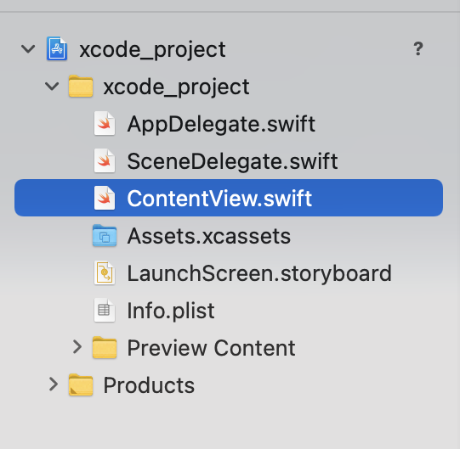

*Screenshot: Navigation Area*

### Editor Area

This is the panel which is used to edit the files. This the main panel where you will work and write all the code for the software and you can view Storyboard files, Swift files or view the project settings.

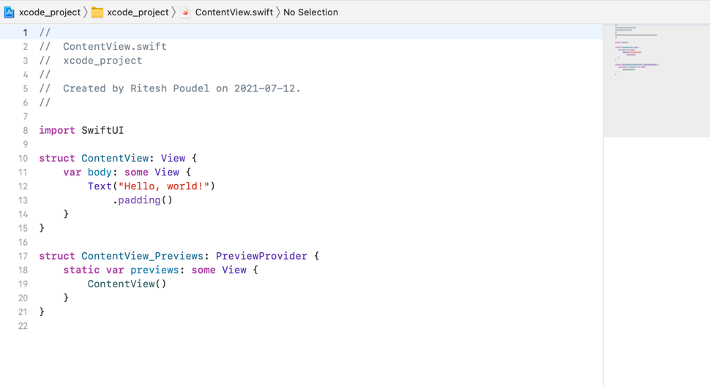

*Screenshot: Editor panel for writing code for the project*

### Utility Area

This panel is a little bit confusing because it changes on the basis of what you have selected in the editor panel and navigation area. It includes properties like file inspector, history inspector, quick help inspector, identity inspector, attribute inspector, size inspector and the connection inspector. Inspector pane allows you to change the attributes or the properties of things you put in your storyboard and the library pane allows you to insert objects, image assets and code snippets into your app.

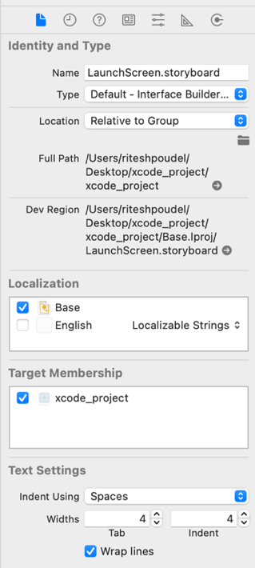

*Screenshot: Utility area for attribute inspector, size inspector*

### Debug Area

In this area, you can see the log message and with the help of this panel, you can get the feedback on what your app is doing or not doing as expected.

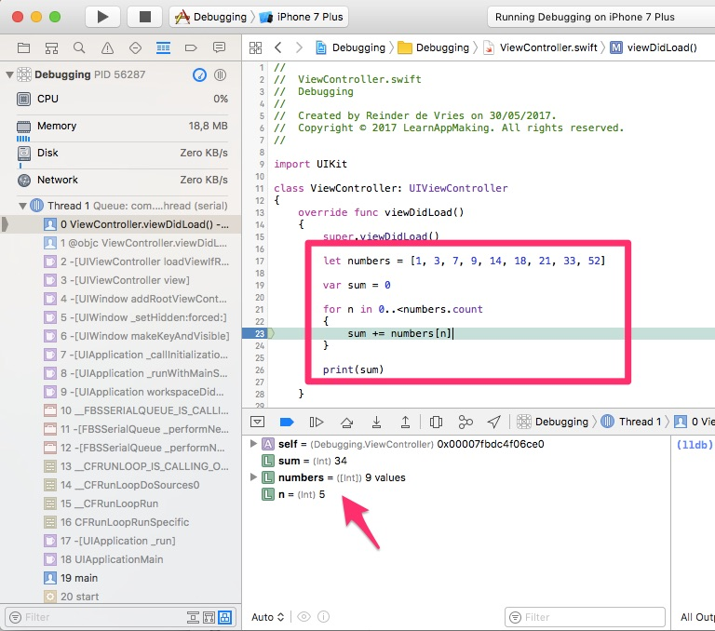

*Screenshot: Debug area in XCode*

# Getting Used to with XCode

Set up fonts and colors, use the tab bar, options, editor, project view, Developer Documentation, Quick Help Inspector, and other tools.

## Font and Color

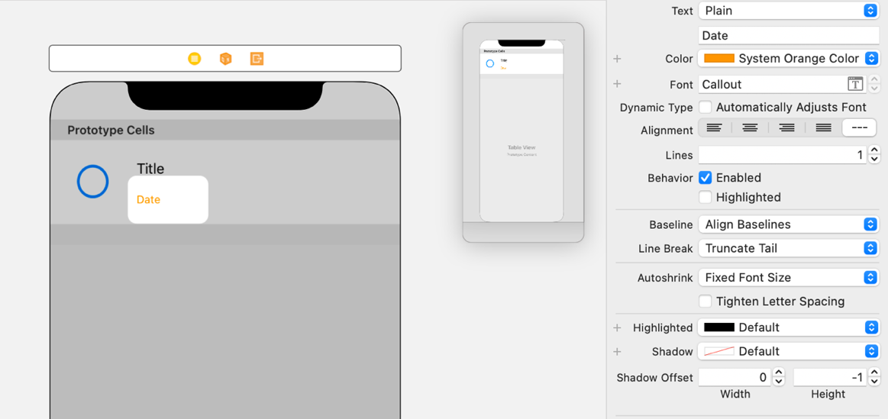

*Screenshot: Font is set to “callout” and color to “orange”*

Through attribute inspector, we can set font, color, texts, alignment and many more for labels, texts etc.

## Tab Bar

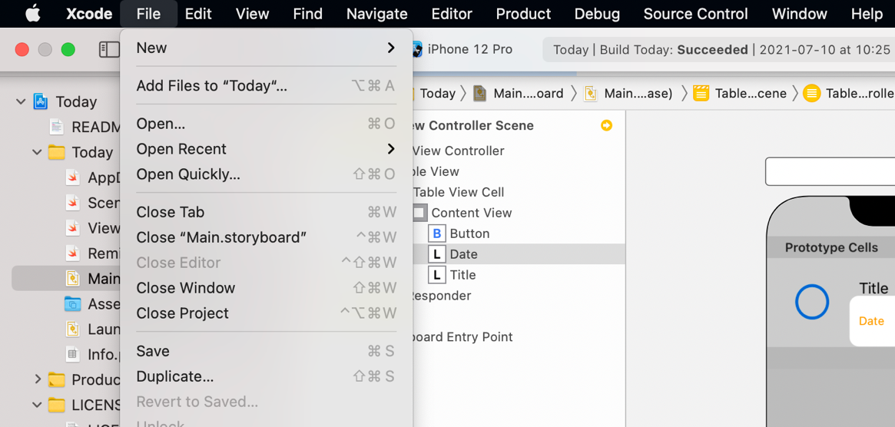

*Screenshot: Exploring tab bar interface of XCode*

Tab bar interface is the top part of the XCode where options like file, edit, view, find, navigate, editor, product, debug, source control, windows and help are present. We can open new file, open project, copy, paste, delete, sort, format, running the project, help function is available there.

## Editor

Editor is the main area where you can write down the actual code for your project, set the design, layout and interface and most of the development work occurs in this area which is the most visible area in the window.

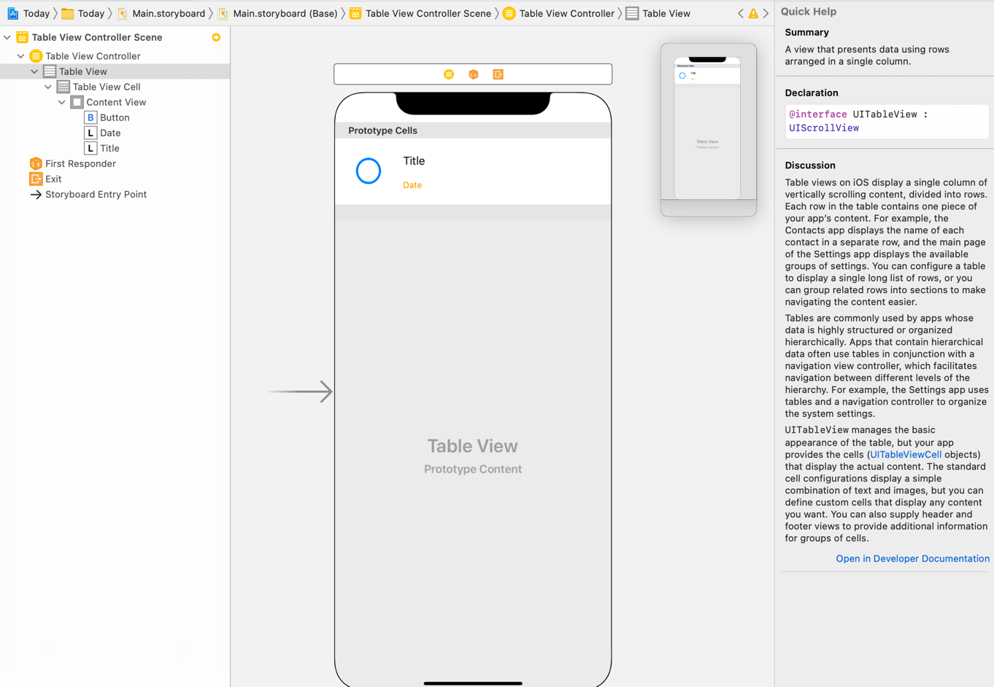

*Screenshot: Editor view on XCode to write code, set up interface*

## Developer Documentation

You can view the latest developer documentation which includes tutorials, sample code, article and API references. Various information about app frameworks, app services, developer tool, graphic and games, media, system and web can be found here. New contents about devices of apples is also available here, you can quickly go there and learn different things. It also displays features and function of upcoming version of XCode as well as Apple products.

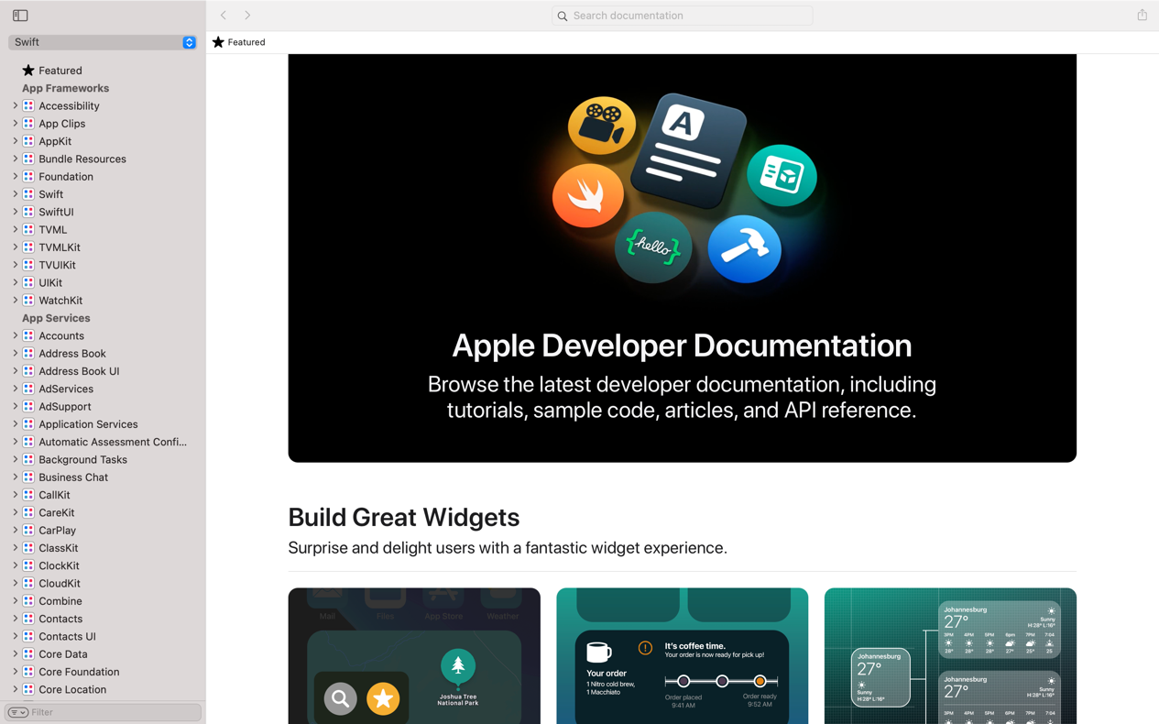

*Screenshot: Apple Developer Documentation*

## Quick Help Inspector

Quick help content is grouped into name sections or related information such as the parameters of a method and it mostly has 4 sections such as description section, parameters section, throws section and return section.

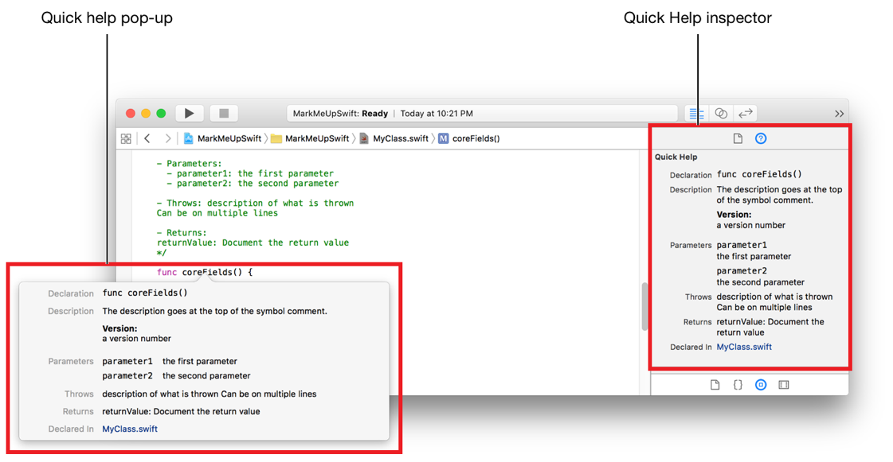

*Screenshot: Quick Help Inspector in XCode*

It is not like that everything have and show something in quick help inspector. Even those which have some information may be in hidden form and it can be enabled.

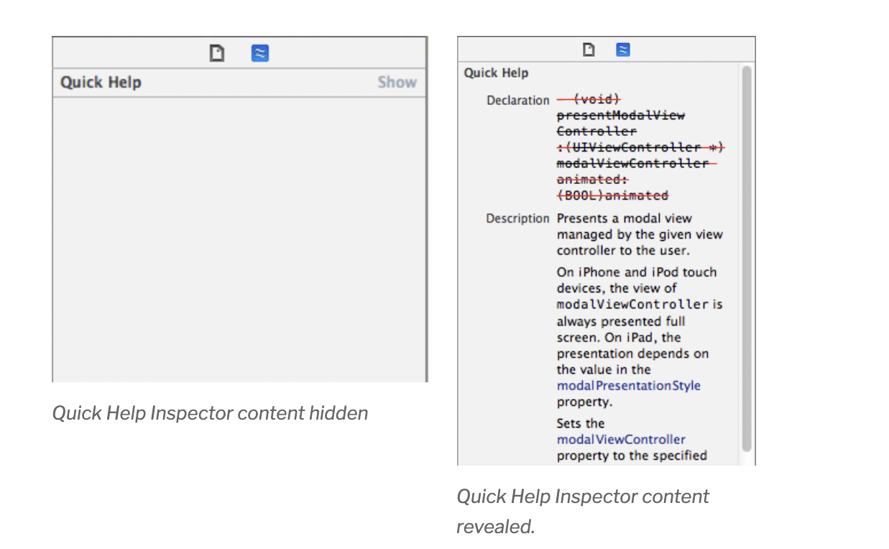

*Screenshot: Enabling content of the quick help inspector*

## Attribute Inspector

Attribute inspector in XCode is a widget which helps to display and edit the selected features from one or more feature layers. It varies and options are different on the basis of selection i.e., for button, labels, text field, switch, table view and many more. It includes options like fonts, background, text label etc.

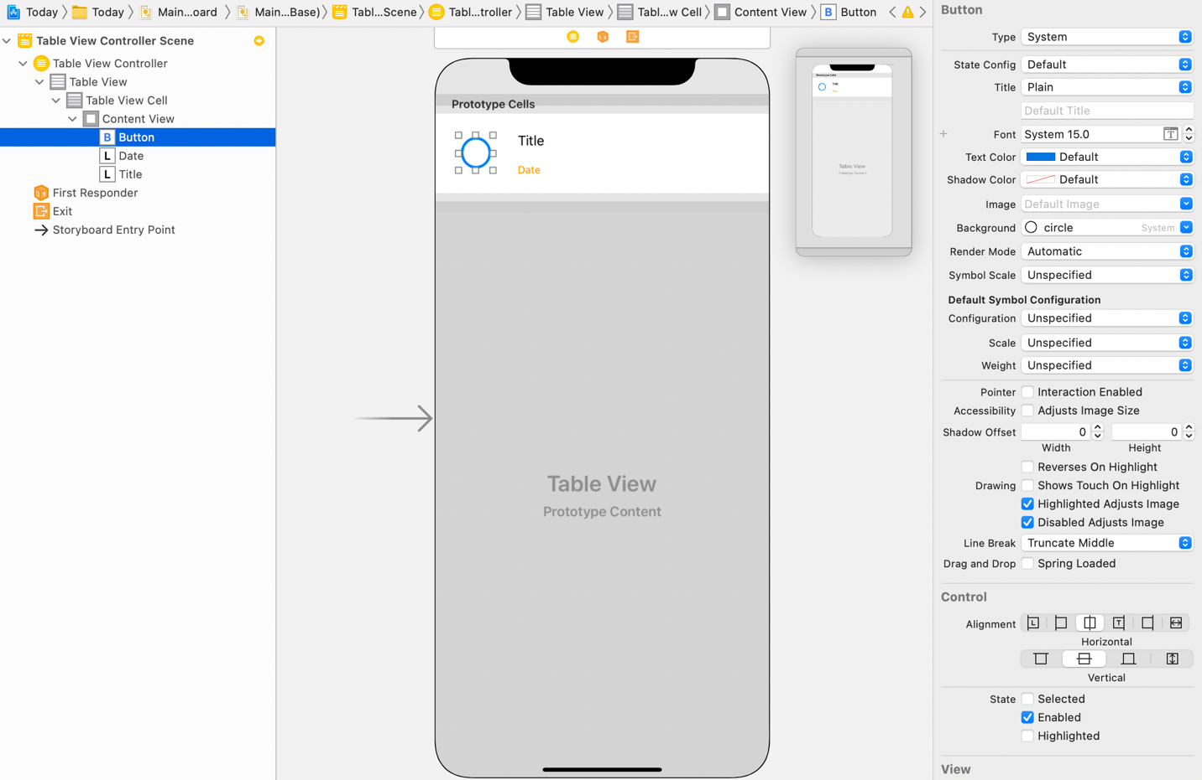

*Screenshot: Attribute Inspector for “Button”*

## Size Inspector

Size inspector appears at the 5th position in the inspector select bar which lets you edit the size and position of an object in your storyboard.

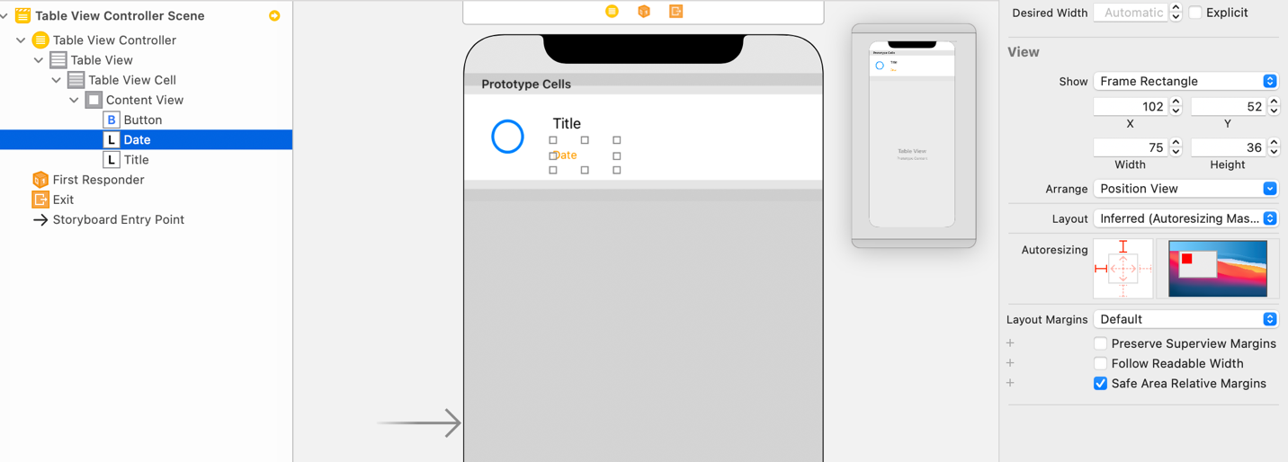

*Screenshot: Size inspector for “Label”*

# References

1. <https://codewithchris.com/xcode-tutorial/>
2. <https://subscription.packtpub.com/book/application_development/9781786464507/1/ch01lvl1sec09/the-xcode-interface>
3. <https://appleinsider.com/inside/xcode>